Physics 4S03 – Molecular Biophysics. Midterm. November 2013.

1. The behaviour of double-stranded DNA can sometimes be explained by a wormlike chain model.
(a) Explain the assumptions of the wormlike chain model. Which features of real DNA are included in the model and which are neglected? (5 marks)
(b) If a wormlike chain of length L and persistence length ξ is bent into a circle, what is its bending energy? (5 marks)

2. According to the Debye-Huckel theory, electrostatic interactions in salt solution are screened at a length scale larger than λ_{D} , the Debye screening length.
(a) Explain what is meant by screening and why it occurs. (5 marks)
(b) How would you expect screening to influence the flexibility of DNA? How can this argument be used to explain experimental observations on the way salt concentration affects the association between DNA and histone proteins? (5 marks)

3. Read the results below from an experiment in which DNA molecules are adsorbed onto a mica surface that has been coated with a positively charged polymer (called PO-49). Answer the questions on p3.
The figure below shows two atomic force microscopy images of adsorbed DNA molecules on surfaces with high and low densities of PO-49 coating.
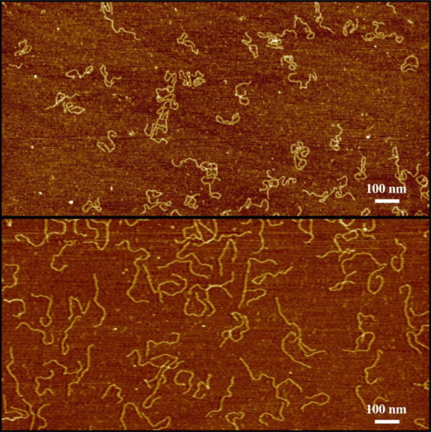

High density PO-49

Low density PO-49

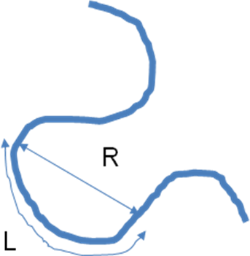
A wormlike chain model in two dimensions was used to explain the shapes of the molecules observed in the images. For any two points on a molecule, let R be the direct distance between them and let L be the contour length measured along the molecule. According to the wormlike chain model, the mean square value of R should be
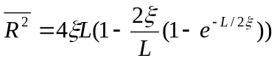, (Eq. 1)
where ξ is the persistence length.

The figure below shows the measured mean square R as a function of L for three different densities of surface coating. Solid lines are fits of the wormlike chain model.
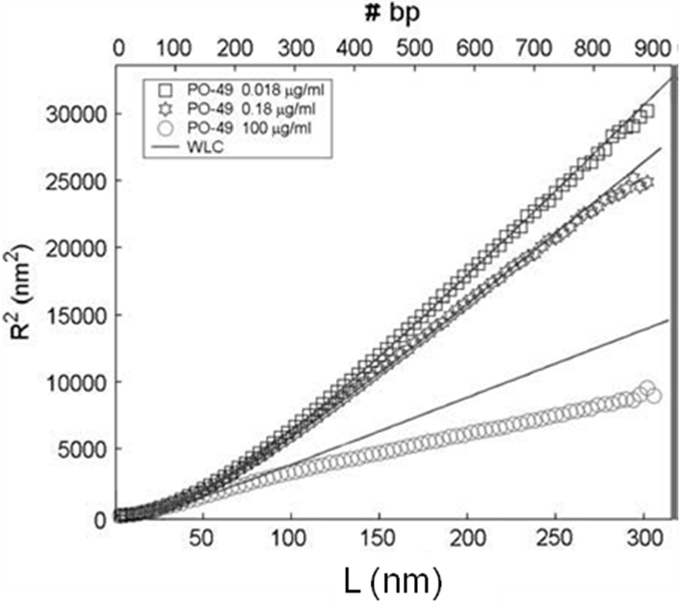

Low density PO-49

Medium density PO-49

High density PO-49

By fitting the model to the data, the persistence length was estimated, as shown in the following table.

Table 1. Measured persistence lengths
Coating | Persistence length (nm)
Uncoated mica surface | 56.5
Low density PO-49 | 32.6
Medium density PO-49 | 26.6
High density PO-49 | 11.3

Question 3

(a) Describe what is observed in these experiments and explain as fully as you can what you think is the reason for the observed behaviour. Why would you expect the surface charge density of the PO-49 to influence the persistence length of the DNA? (5 marks)

(b) According to Equation 1, how does R² scale with L when L is much less than ξ and when L is much greater than ξ? Give a simple physical argument to explain these scalings. (5 marks)

(c) The wormlike chain model does not seem to fit the data very well for the high density coating. Can you suggest some possible reasons for this? (5 marks).

Total 35 marks.

